
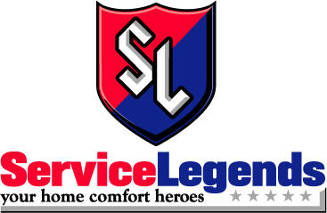

Photo Opportunity Contact: Scott Allen

For Immediate Release Operations Manager
November 23, 2011 (515) 309-4276
sallen@desmoinesradiogroup.com

21 Years of Giving Back to Central Iowa
STAR 102.5 Teams with Service Legends to Continue a Holiday Tradition

Des Moines, IA – Once again, STAR 102.5 KSTZ is giving listeners the chance to help people in their community with “STAR 102.5’s Christmas Wish.” STAR 102.5 KSTZ has been granting wishes for deserving Central Iowans for 21 years, and this year STAR 102.5 KSTZ will continue the tradition with the help of Service Legends Heating and Cooling.

“Each year we are able to help more than a dozen families in the metro through illness, lay-offs, loss and more. We’re honored that they trust us with their stories and we do our best to help where we can,” says Scott Allen, Program Director for STAR 102.5 KSTZ.

For Service Legends Heating and Cooling, signing on as the presenting sponsor for
“STAR 102.5’s Christmas Wish” just made sense. “Service Legends prides itself on being good stewards to the community; we are big supporters to local charities. Helping with this tradition was a natural fit,” says Brian Leech, Owner of Service Legends Heating and Cooling.

Listeners in the greater metro are encouraged to submit a Wish for their family, friends, co-workers or neighbors at www.STAR1025.com. Wishes are considered by a committee based on criteria from need to grant ability.

The Des Moines Radio Group consists of five FM and two AM stations in Des Moines: 93.3, KIOA; STAR 102.5, KSTZ; LAZER 103.3, KAZR; LITE 104.1, KLTI; The HITS 99.9; PRAISE 940, KPSZ; and AM 1350, KRNT. Des Moines Radio Group is a division of Saga Communications, Inc. of Grosse Point Farms, Michigan. For more information, visit www.desmoinesradiogroup.com.

# # #

